# Communicate with friend

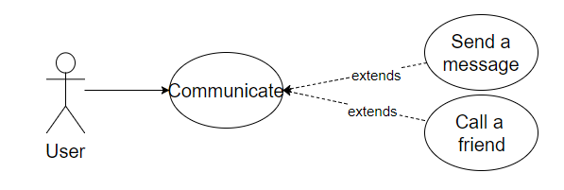

## Characteristic Information

|  |  |
| --- | --- |
| Goal: | The user communicate with friends in term of sending messages or talking. |
| Precondition: | The user has to have at least one friend to be able to communicate with.  And for the calling he/she needs to accept the call. |
| Postcondition: | The user communicated with a friend. |
| Involved User: | The user and one or more of his/her friends |
| Triggering Event: | The user wants to call or to chat someone. |

## Scenarios for the standard use

| Step | User | Activity |
| --- | --- | --- |
| 1 | User | Log in |
| 2 | User | Select friend |
| 3 | User | Call the selected friend |

Or:

|  |  |  |
| --- | --- | --- |
| 3 | User | Write a message |
| 4 | User | Send the message |

## Open Points

Characters:

The application will not support every characters and because of that some messages will be shown differently (e.g. Japanese symbols, Russian characters, etc.).